A MORE EFFICIENT APPROXIMATION SCHEME FOR TREE ALIGNMENT
LUSHENG WANG, TAO JIANG, AND DAN GUSFIELD
SIAM J. COMPUT. Vol. 30, NO 1, pp. 283-299
- Introduction
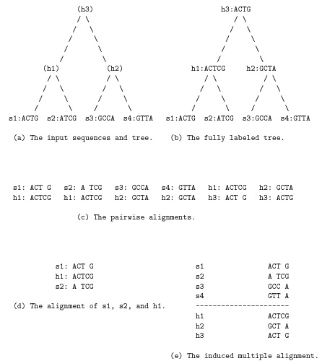
2. Uniformly lifted trees and the general approach.
3. The new partitioning strategy and algorithm.
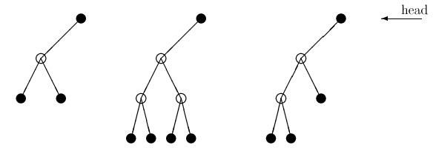
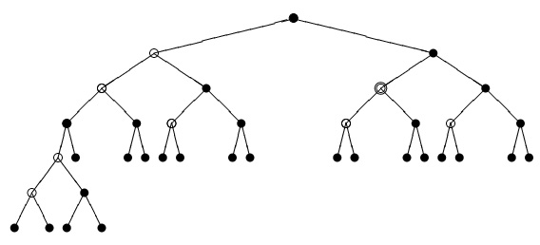
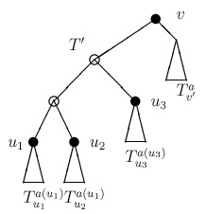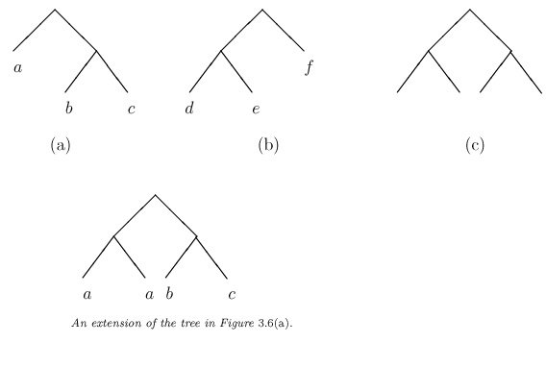
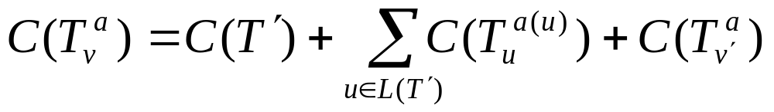
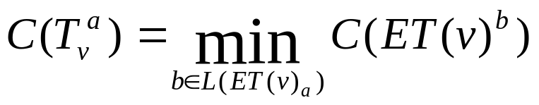
Created by: Ing-Jer Liao
Date: April 23, 2002

